1. What is Faraday’s Law? Explain in words, and also with equation(s). Can you make sense of the equation and tell “The Story of Faraday’s Law in words”?

Faraday’s law provides a way to predict how a magnetic field interacts with other components to produce electro motive force (emf), its negative due to it being induced from Lenz’s Law, and it based off the change of magnetic flux and area with respect to time. This means that the shorter time that is spent and the larger area and stronger flux, the greater the emf will be. So a massive B with a large A in a very short amount of time will have quite a large (negative) emf value.

Where Φ = B\*A

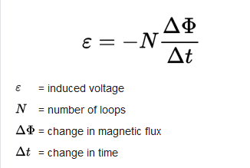

1. Describe, you can also draw, what did you see in the demonstration. Explain, you can draw, but you also need to use your words

As there was more B to go through, the drag that the magnet fought through increased. So, with the larger diameter pipe, it fell at a slower rate in comparison to the smaller diameter pipe. But when the smaller pipe is placed into the wider pipe, and then the magnet was sent down, it fell at a rate slower than either of them alone. Watching the magnet as it fell, the magnet was in the middle not making contact unless the pipes were at an angle instead of a vertical

1. Using Faraday’s Law, explain what you are seeing in the demo?

As the magnets falls, it creates a change in the magnetic flux density which induces emf causing it to dampen the pull of gravity on the magnet as it falls. The induced emf creates a weaker magnetic flux density that dampens the pull of gravity on the magnet as it descends. The thickness of the pipe allows for B to be larger further dampening the descent, this was observed when the smaller pipe was placed within the larger pipe and then the magnet was sent through the pair.